WEEK 5

Aim:
To enhance the Week 4 webpage using JavaScript and to perform JavaScript form validation along with basic Node.js and NPM operations.

Description:
This experiment consists of two parts. In the first part, the Week 4 login dashboard is enhanced with a JavaScript setTimeout() callback function to redirect the user to the login page after 10 seconds of inactivity. In the second part, JavaScript-based HTML form validation is performed, followed by exploring Node.js installation, REPL, and NPM operations.

Part 1: Enhancement of Week 4 Experiment
Implement a 10-second inactivity timer using JavaScript.
Program Code:
- Success page modified :

<html>
<head>
<title>Success-Page</title>
<meta name="viewport" content="width=device-width">
<meta charset="UTF-8">
<style>

body{
background-color: aliceblue;
background-image: url("./bgimage.jpg");
}
.heading{
height: 180px;
display: flex;
align-items: center;

}
.heading img{
height: 100px;
width: 100px;
margin-left: 20px;

}
.text{
flex:1;
display: flex;
align-items: center;
justify-content: center;
flex-direction: column;
color: azure;

}
.navbar{
margin-top: 0px;
height: 50px;
display: flex;
flex-direction: row;
justify-content: space-around;
background-color: purple;
}
a{
color: white;
text-decoration: none;
margin-top: 10px;
}
.box{
margin-top: 50px;
height:500px;
width: 600px;
margin-left: auto;
margin-right: auto;
background-color: lightblue;
box-shadow: 10px 10px 10px grey;
display: flex;
flex-direction: column;
justify-content: space-around;
}
.inner{
background-color: aliceblue;
border-left: 5px solid yellow;
margin-left: auto;
margin-right: auto;
width: 90%;
align-self: center;

}
li{
margin-left: auto;
margin-right: auto;
color: blue;
margin-left: 8px;
}
#greeting{
color: blue;
margin-left: 10px;
}
#loginTime{
color: blue;
margin-left: 10px;
}
.f1{
background-color: purple;
height: 50px;
display: flex;
align-items: center;
justify-content: center;
margin-top: 50px;
}
.f1 p{
color: white;

}
</style>
</head>
<header>
<div class="heading">
<img src="Logo.jpeg" alt="Logo">
<div class="text">
<h1>Anil Neerukonda Institute of Technology & Sciences</h1>
<h2>Campus Placement Portal</h2>
</div>
</div>
</header>
<div class="navbar">
<a href="#">Home</a>
<a href="#">About</a>
<a href="#">Apply Job</a>
<a href="#">UpComing Placements</a>
<a href="#">Contact</a>
</div>

<body>
<div class="box">
<h2 style="color: green; margin-left: 10px;">Login Successfull!</h2>
<p style="color: darkblue;margin-left: 10px;">Welcome to ANITS Central Placement Portal</p>
<p id="loginTime"></p>
<p id="greeting"></p>
<div class="inner">
<h2 style="color: blue; margin-left: 5px;">Important Notice</h2>
<ul>
<li>Please contact the <b>Training & Placement Office</b> regularly for updates.</li>
<li>Stay informed about the latest <b>MAANG Companies Recruitment Process.</b></li>
<li>Check your registered Email ID and Placement Portal for Announcements.</li>
<li>Attend all Pre-Placement Talks (PPTs),Aptitutde Training,Mock Interviews and Campus Drives</li>
<li>Keep your Resume,Academic Documents, and ID Card ready before every Recruitment process.</li>
</ul>
</div>
</div>
<footer class="f1">
<p>&copy 2026 ANITS | Department of Training and Placement</p>

</footer>
<script>
function timer(){

alert("Login time-out");
window.location.href="login-dashboard.html";
}

let timeOutId=setTimeout(timer,10000);
function resetTime(){
clearTimeout(timeOutId);
timeOutId=setTimeout(timer,10000);
}
document.addEventListener("click",resetTime);
document.addEventListener("mouseover",resetTime);
document.addEventListener("keyup",resetTime);
document.addEventListener("keydown",resetTime);
document.addEventListener("input",resetTime);
document.addEventListener("submit",resetTime);
let now=new Date();
let hours=now.getHours();
let greet="";
if(hours<12){
greet="Good Morning!";
}
else if(hours<17){
greet="Good Afternoon!";
}
else if(hours<21){
greet="Good Evening!";
}
else{
greet="Good Night!"
}
document.getElementById("greeting").innerHTML=greet;
document.getElementById("loginTime").innerHTML="Login Time :"+now.toLocaleTimeString();

</script>
</body>
</html>
Output:

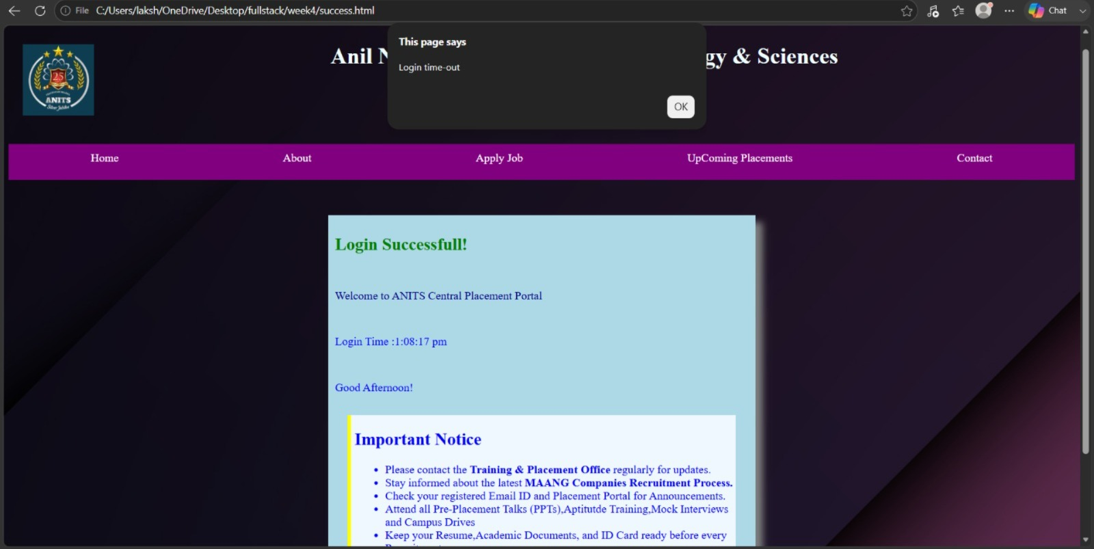

Part 2: JavaScript Form Validation and Node.js Basics

2.1 JavaScript-based HTML Form Validation.

Program Code:
<html>
<head><title> form validation</title>
</head>
<body>
<form onsubmit="return validateForm()">

<label>Name:</label>
<input type="text" id="name">

<br><br>

<label>Email:</label>
<input type="email" id="email">

<br><br>

<button type="submit">Submit</button>

</form>

<p id="error"></p>

<script>
function validateForm() {

let name = document.getElementById("name").value.trim();
let email = document.getElementById("email").value.trim();
let error = document.getElementById("error");

error.innerHTML = "";

if (name === "") {
error.innerHTML = "Name is required";
return false;
}

if (email === "") {
error.innerHTML = "Email is required";
return false;
}

alert("Form submitted successfully");
return true;
}
</script>
</body>
</html>

Output:

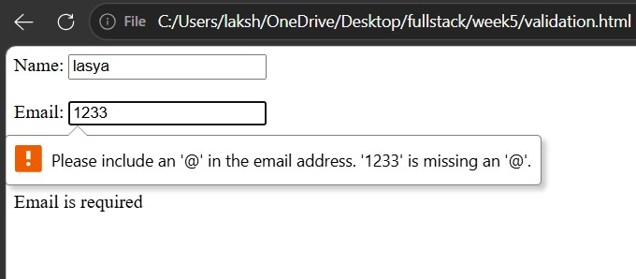

2.2 Node.js installation and verification, Node.js REPL practice, NPM – creation of package.json and installation of Express.

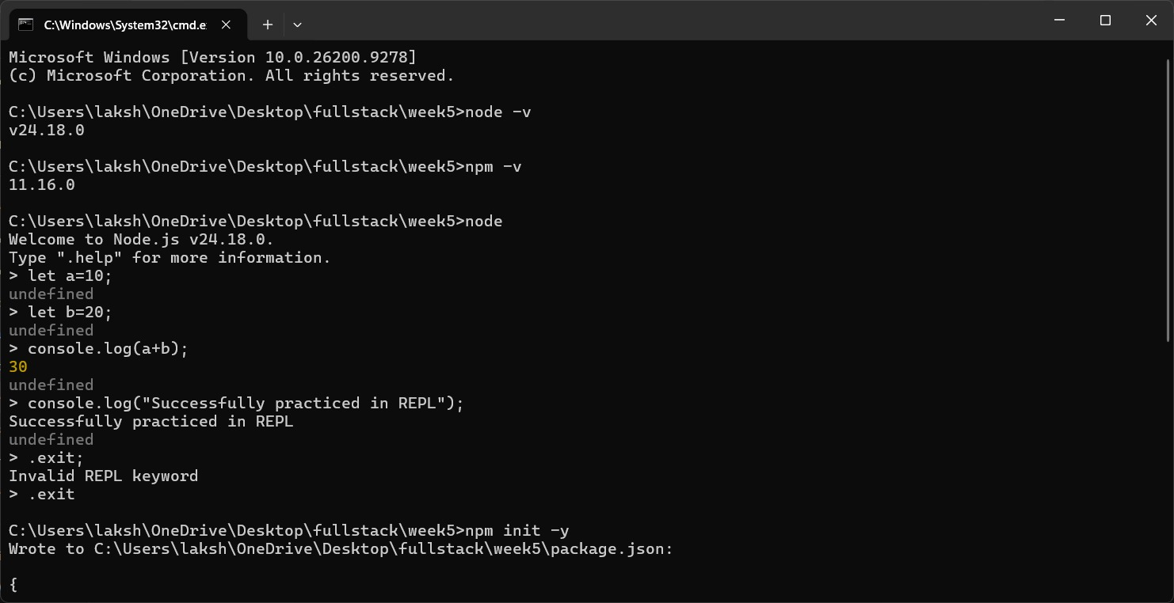
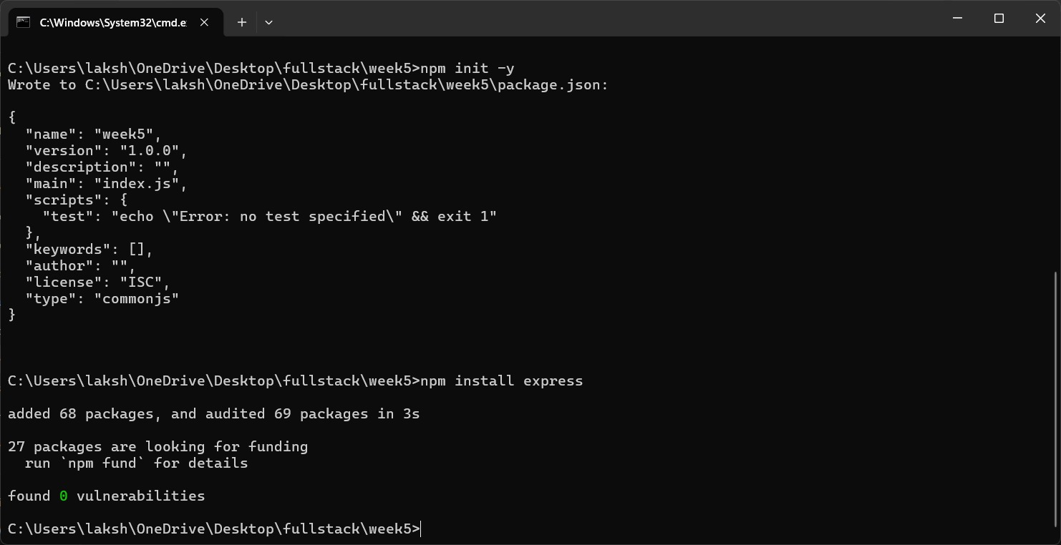

Details About Program:
Saved in: Week 5 folder of the repository.
Technologies used: HTML, CSS, JavaScript and Node.js.
Part 1 Execution: The enhanced HTML page is opened in a web browser.
Part 2 Execution: Form validation is executed in a web browser, while Node.js and NPM programs/commands are executed using the terminal or Command Prompt.
Working: Part 1 implements automatic redirection after 10 seconds of inactivity. Part 2 validates HTML form inputs and explores Node.js, REPL and NPM operations.

Result:
The Week 4 webpage was successfully enhanced with a 10-second inactivity timer. JavaScript form validation was performed, and Node.js, REPL and NPM operations were successfully explored.

